**SHIP TO:**

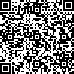

**WORLDWIDE TICKETCRAFT**

**3606 Quantum Blvd**

**Boynton Beach, FL 33426**